Military Institute of Science and Technology
Department of Computer Science and Engineering
Course Title: Data and Tele-Communication Sessional
Course Code: CSE-318, Cr. Hr: 1.50
Level-3, Term-2

Experiment No. 06

Name of the Experiment: T.D.M Modulation and Demodulation

OBJECTIVE:

The objective of this experiment is to gain practical introduction to time division multiplexing (TDM) through the following topic areas.
  - Introduction to time division multiplexing (TDM)
- The TDM transmitter
- Synchronization
- The Demultiplexer and Demodulator
- The complete PAM-TDM system

Equipments needed:

- MODICOM 2 board.
- IC Power 60 unit
- Set of connection leads.
- Multimeter.
- Oscilloscope.

Theory:

The sampling theorem provides the basis for transmitting the information contained in a band limited signal m (t) as a sequence of samples of m (t) taken uniformly at a rate that is usually slightly higher than the Nyquist rate. An important feature of the sampling process is the conservation of time. That is, the transmission of the sample engages the communication channel for only a fraction of the sampling interval on a periodic basis, and in this way some of time interval between adjacent samples is cleared for use by other independent message sources on time shared basis. We, thereby, obtain a Time Division Multiplex (TDM) system, which enables the joint utilization of a communication channel by a plurality of independent message sources without mutual interference among them.
The information can be sent in the amplitude, duration or position of pulses, this will give rise to:
- A PAM signal (Pulse Amplitude Modulation).
- A PWM signal (Pulse Width Modulation).
- A PPM signal (Pulse Position Modulation).
The Time Division Multiplexing (TDM) technique, in general, consists of the simultaneous sending of several signals through only one medium of transmission. What is actually done is to intercalate different signal samples within a single sampling interval (the time that elapses between two consecutive samples of the same signal), and to transmit the set as a single signal through one medium of transmission. In order to recuperate all the signals properly, the receiver must separate the different samples that reach it in the correct order and direct each one of them to its assigned output channel for its recovery.
So there must be correct synchronization between the commutator (an electronic switch, in the transmitter side) and the decommutator (an electronic switch, in the receiver side). This synchronization is essential for a satisfactory operation of the system. See the figure below:

Procedure:

We can achieve complete PAM-TDM system by using three modes of connection.

Mode 1: Three links between Transmitter and Receiver:
A simple method of TDM transmission is to provide three connections between the sending and receiving end. One channel for message, another for clock and another for frame synchronization.
Connections:
Tx output to Rx input
Tx CH0 to Rx CH0
Tx Clock to Rx Clock
See figure 1 for connections.

Mode 2: Two links between Transmitter and Receiver:
Message signal and frame synchronizing signal is transmitted and clock is generated at receiver by PLL.
Connections:
Tx output to Rx input
Tx CH 0 to PLL I/P
Sync of PLL to RX CH 0
CLK of PLL to Rx Clock
See figure 2 for connections.

Mode 3: One link between Transmitter and Receiver:
TDM can be achieved using only one link and so achieve significant transmission medium savings.

Connections:

Sync Level to CH 0
Tx output to Rx input
Sync of PLL to Rx CH0
CLK of PLL to Rx Clock
See figure 3 for connections.

- Put duty cycle ON position by rotating the knob. Keep at around 20%. You can observe the sampling clock signal at P7, P8, P9 and P10. Observe the differences of the clock signals at these points.
- Check that all switched faults are in OFF position.
- Operate the TDM by Mode 1 connection. Figure 1 gives the basic Mode 1 connection diagram. Observe the wave shapes at TX output at P20 and before and after low pass filtering at P42 and P43 respectively for CH0. Observe P44 and P45 for CH1, P46 and P47 for CH2, P48 and P49 for CH3.
- Repeat the above steps using Mode 2 connection. Figure 2 gives the basic connection diagram. To change the amplitude of the input signal very the knob associated with the input signal clockwise.
- Repeat the above steps using Mode 3 connection. Figure 3 gives the basic connection diagram.

Report:

- Show the wave shapes, observed in the experiment, in graph papers with corresponding pin numbers.
- What do you mean by TDM modulation and demodulation?
- Why synchronization is necessary in the receiver circuit?
- What is the major advantage of TDM over FDM?
- Describe the operation of PLL. What is the function of ‘divided by 4 counter’ and ‘delay’ in the PLL of this Trainer?

Reference:

- MODICOM 2 Manual
- Modern Digital and Analog Communication Systems --- B.P. Lathi
- Communication Systems --- Haykin

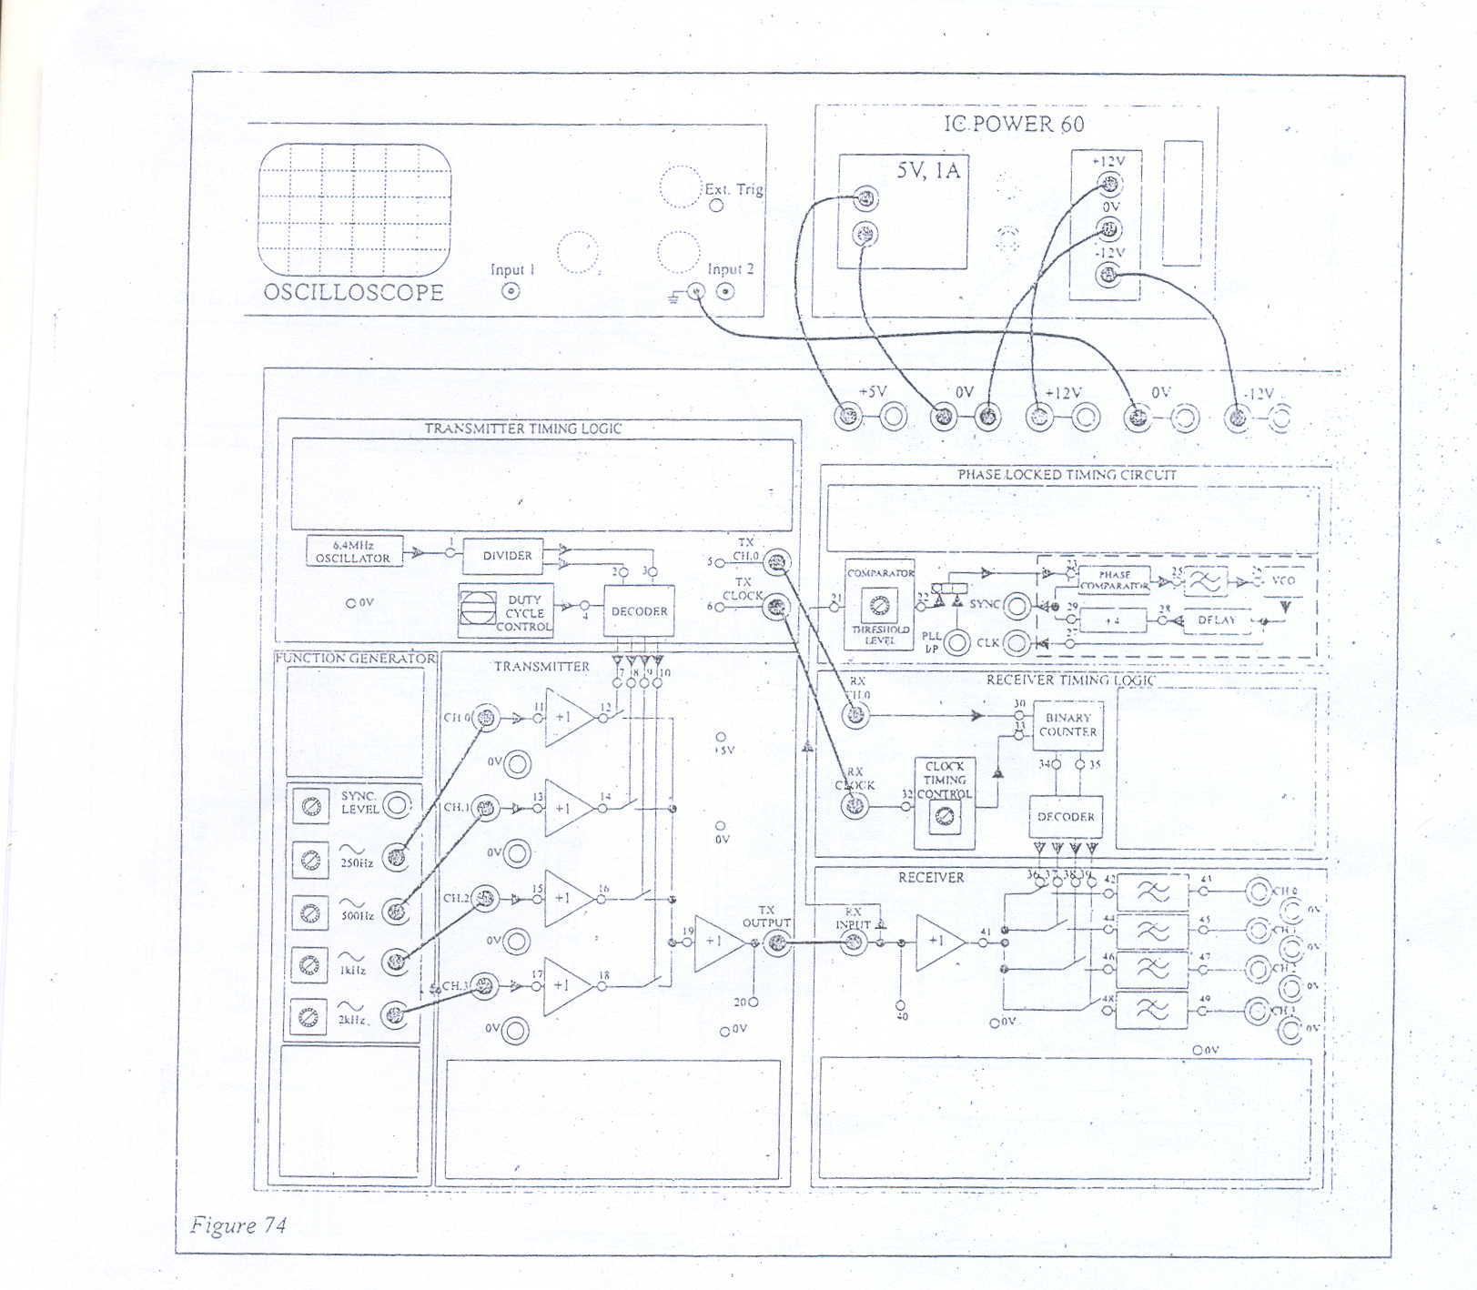
Figure 1: Connection of Mode 1 TDM

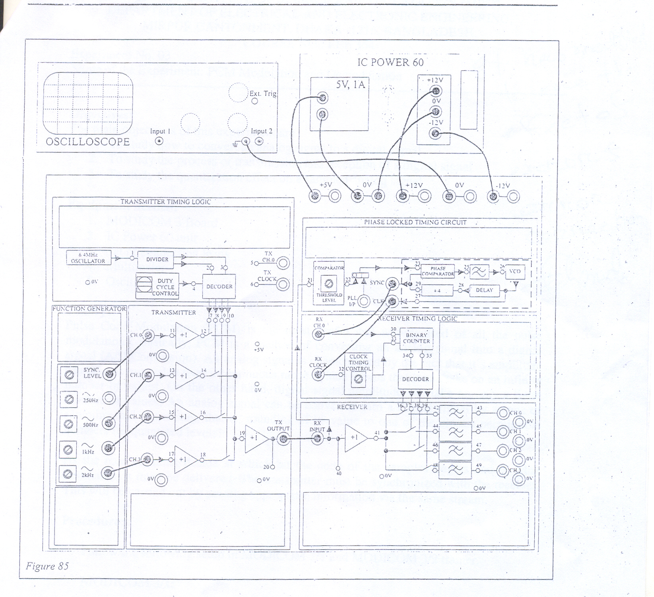
Figure 3: Connection of Mode 3 TDM

